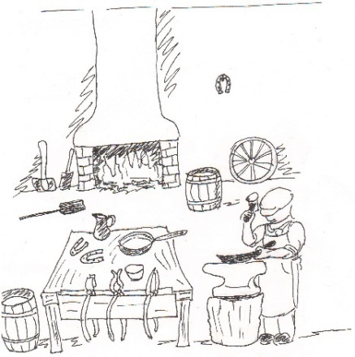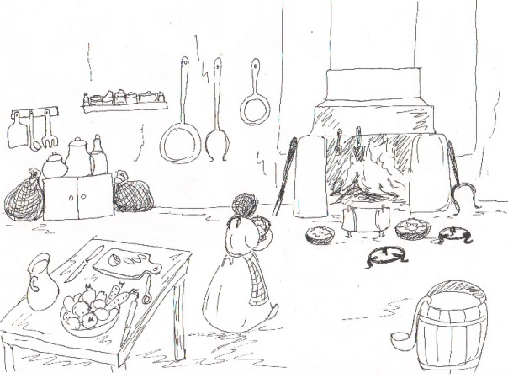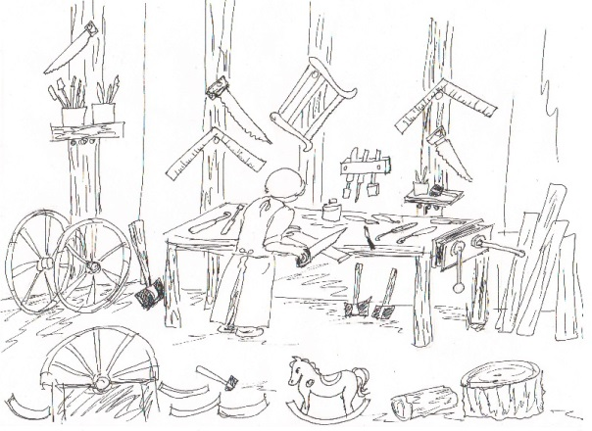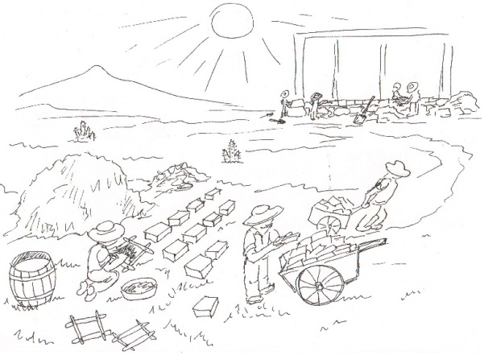
Blacksmith
Domestic- Cook
Carpenter
Laborer- Adobe work
Directions: Circle the picture that shows a 19th century job you would like to write about.
Now write a paragraph that tells about the picture you circled. You do not have to use all the lines. Just write on as many as you need.
______________________________________________________________________________________________________________________________________________________________________________________________________________________________________________________________________________________________________________________________________________________________________________________________________________________________________________________________________________________________________________________________________________________________________________________________________________________________________________________________________________________________________________

